Customer Shopping Behaviour Analysis
1. Introduction
This project focuses on examining customer shopping patterns using a dataset containing 3,900 purchase transactions from multiple product categories. The objective was to gain meaningful insights into customer purchasing habits, spending behaviour, product preferences, and subscription trends. The findings can help businesses make informed decisions regarding marketing strategies, customer retention, and revenue growth.
2. Dataset Description
The dataset consists of 3,900 records and 18 variables that capture different aspects of customer behaviour and purchasing activity.
Key Variables Included:
- Customer information such as age, gender, location, and subscription status.
- Transaction details including purchased products, categories, purchase amounts, seasons, sizes, and colors.
- Shopping behaviour indicators such as discount usage, promotional codes, purchase frequency, previous purchases, review ratings, and shipping methods.
Data Quality Assessment
During the initial inspection, 37 missing values were identified in the review rating column. These missing values were addressed during the data preprocessing stage to ensure reliable analysis.
3. Data Preparation and Exploration Using Python
The analysis began with data cleaning and preprocessing using Python.
Data Import and Exploration
The dataset was loaded into Python using the pandas library. Preliminary exploration was performed using functions such as info() and describe() to understand the dataset structure, variable types, and statistical summaries.
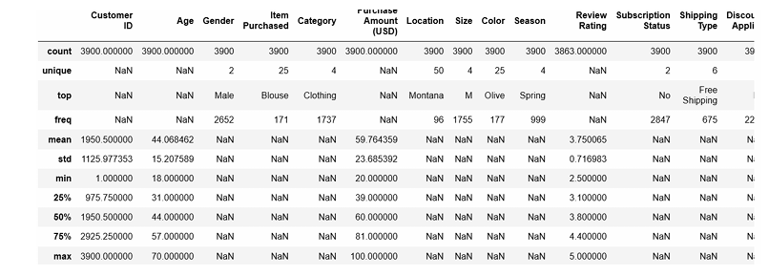
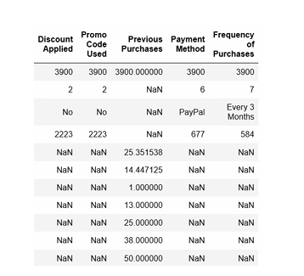
Handling Missing Values
Missing review ratings were replaced using the median rating within each product category, ensuring that the imputed values reflected category-specific customer feedback patterns.
Standardizing Data
Column names were reformatted into snake_case notation to improve readability and maintain consistency throughout the analysis process.
Feature Engineering
Additional variables were created to enhance analytical capabilities:
- An age_group variable was generated by categorizing customers into different age ranges.
- A purchase_frequency_days variable was created to better represent customer buying patterns.
Data Validation
A consistency check revealed that the variables discount_applied and promo_code_used contained overlapping information. As a result, the promo_code_used column was removed to reduce redundancy.
Database Integration
After preprocessing, the cleaned dataset was transferred into a BigQuery database, enabling efficient SQL-based business analysis.
4. Business Analysis Using SQL
Several business-oriented questions were addressed through SQL queries.
Revenue by Gender
Revenue contributions from male and female customers were compared to determine which customer segment generated greater sales.
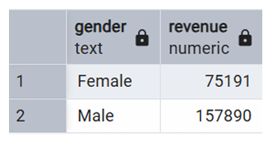
High-Spending Customers Using Discounts
Customers who utilized discounts while maintaining purchase amounts above the overall average were identified to understand spending behaviour among discount users.
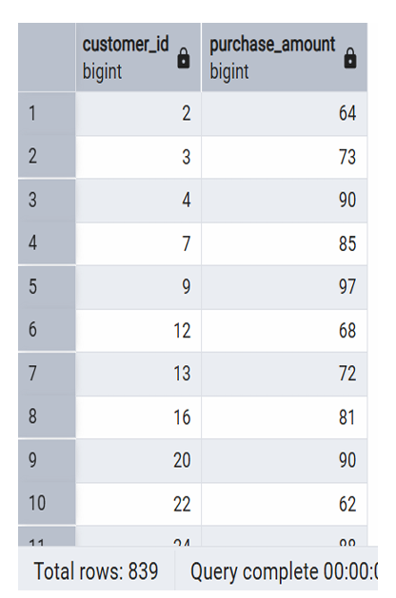
Top-Rated Products
Products were ranked according to their average customer review ratings, allowing identification of the five highest-rated products.
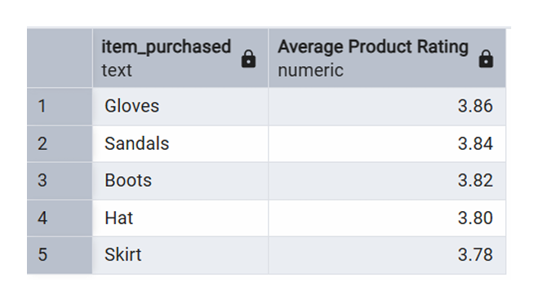
Shipping Method Analysis
The average purchase amount associated with Standard and Express shipping methods was compared to evaluate spending differences across shipping preferences.
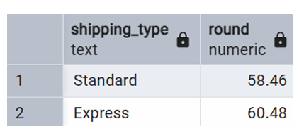
Subscription Status Analysis
A comparison between subscribed and non-subscribed customers was conducted using average spending and total revenue metrics. The results indicated that non-subscribers generated higher total revenue and exhibited a slightly higher average purchase amount than subscribers.
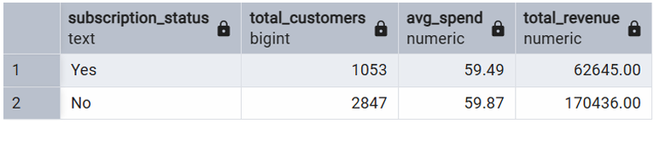
Products with Highest Discount Usage
Products with the greatest proportion of discounted purchases were identified, highlighting items that customers most frequently purchased with discounts.
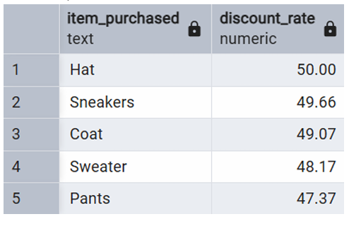
Customer Segmentation
Customers were categorized into New, Returning, and Loyal groups based on their purchase history to better understand customer retention and loyalty patterns.
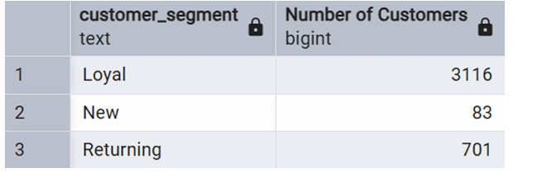
Top Products Within Categories
The three most frequently purchased products from each product category were determined to identify category leaders.
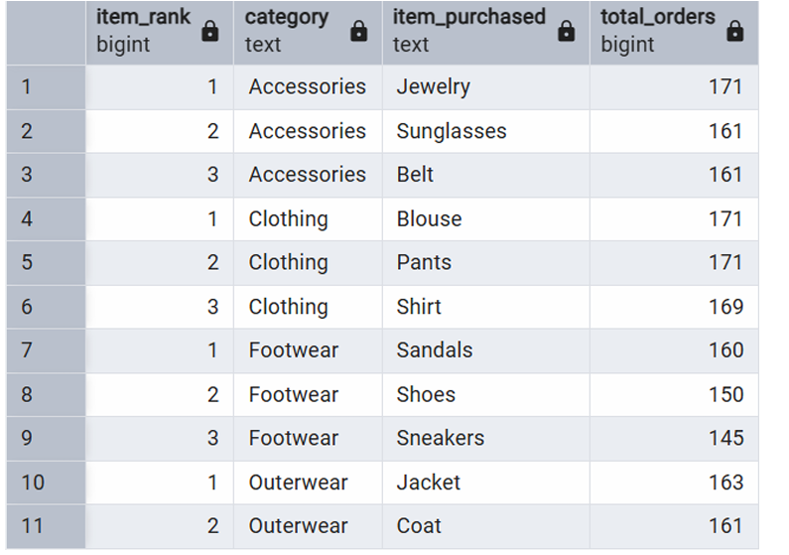
Repeat Purchase and Subscription Relationship
The analysis investigated whether customers with more than five previous purchases were more likely to hold a subscription.
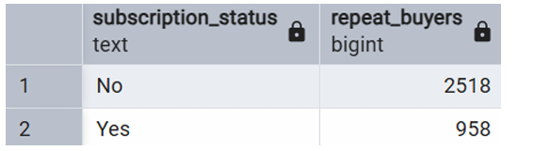
Revenue Contribution by Age Group
Total revenue generated by different age groups was calculated to determine which age segments contributed most significantly to sales.
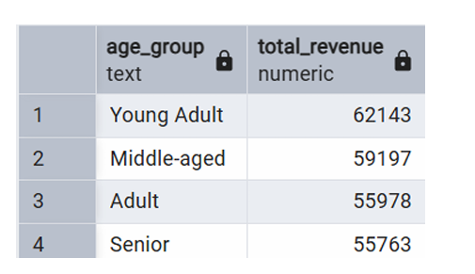
5. Dashboard Development in Power BI
A comprehensive Power BI dashboard was developed to visualize the analytical findings. Interactive charts, filters, and performance indicators were incorporated to provide stakeholders with an intuitive and dynamic view of customer behaviour, sales trends, and product performance.
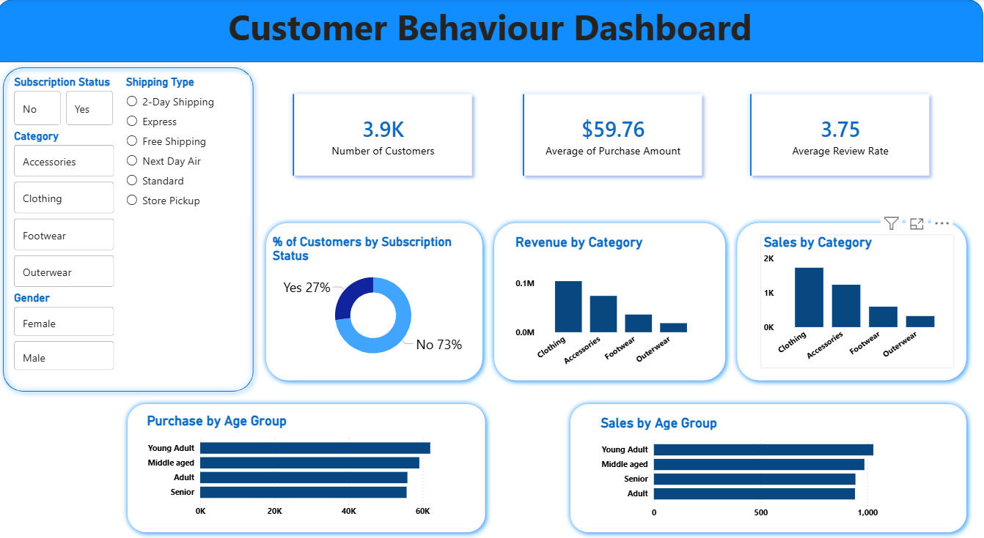
6. Recommendations
Based on the analysis, the following recommendations are proposed:
Enhance Subscription Programs
Introduce attractive subscription benefits, loyalty rewards, and exclusive promotions to encourage more customers to subscribe.
Strengthen Customer Retention
Implement customer loyalty initiatives that reward repeat purchases and motivate customers to progress into the loyal customer segment.
Optimize Discount Strategies
Regularly evaluate discount campaigns to ensure they increase sales without significantly reducing profit margins.
Promote High-Performing Products
Leverage top-rated and best-selling products in advertising and promotional campaigns to maximize customer engagement and sales.
Improve Targeted Marketing
Focus marketing efforts on age groups and customer segments that contribute the highest revenue, while also tailoring promotions based on shipping preferences and purchasing behaviour.
Conclusion
This project successfully combined Python, PostgreSQL, and Power BI to transform raw transaction data into meaningful business insights. Through data cleaning, exploratory analysis, SQL-based business intelligence, and dashboard visualization, valuable patterns in customer behaviour, product performance, and purchasing trends were identified. These insights can support data-driven decision-making and help businesses improve customer satisfaction, retention, and overall profitability.

